20-02-23

PoA: Aan de slag voor een lach

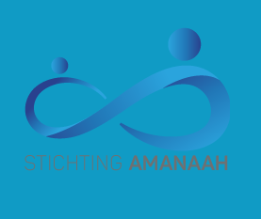

AUTHORS

Sanae el Ouahabi, Nisrine Hajjab,

Amber Tallih & Iman Djebari

# INFORMATION

## **AUTHORS**

*Sanae El Ouahabi is the team leader of this group and I am 16 years old. I am in my fourth year of VWO gymnasium/Technasium. In my spare time I like to read, and I also like doing gymnastics.*

*Nisrine Hajjab is a team member of this group and I am 15 years old. I like to read in my spare time and to draw and I also* like to go to the gym even though I don’t do it as much.

*Amber Tallih is a team member of this group and I am 15 years old.* I like spending time with my friends and family. I also like to read books and watch series.

*Iman Djebari is a team member of this group and I am 15 years old.* I love spending time outside playing sports and being active.

**WEBSITES**

To get access to our group site, you should click on the following link:

<https://aan-de-slag-voor-een-lach1.webnode.nl/>

(Aan de slag voor een lach, 2021)

From here you can easily access our personal portfolios. Each team member has its own website, where you can find our personal development plan.

## **PROFFESSORS**

Gerard van Soelen, teaches the subject O&O.

Contact information, [gvansoelen@calandlyceum.nl](mailto:gvansoelen@calandlyceum.nl)

Mariëlle van den Ende, teaches the subject O&O.

Contact information, [mvandeende@calandlyceum.nl](mailto:mvandeende@calandlyceum.nl)

## **COMMISSIONING PARTY**

Our client is Mr. Huizer from the foundation Amanaah. He is the general manager of The Foundation Amanaah in the Netherlands. The following mail and phone number are the contact information of our client.

Mail: [stichtingamanaah@gmail.com](mailto:stichtingamanaah@gmail.com)

Phone number: 0622405640

## **IMPORTANT DATA**

The start of the project: 09-01-23

The end of the project: 05-06-23

Technasium parade: 12-06-23

# PREFACE

Our team consists of the following people: Sanae El Ouahabi, Nisrine Hajjab, Amber Tallih and Iman Djebari. The intentions we had when we chose this commissioning party was to help people In need and especially to offer all the children a future. The one thing we are most excited about is to help the people who are struggling with water. With our contribution we hope to help the foundation Amanaah in their goal to make the world a better place for countries that are struggling, beginning with the people in Gambia.

## **TECHNASIUM RESEARCH & DEVELOPMENT**

At the Technasium we follow the course R&D (research & design). At R&D you receive assignments from clients that you try to complete as well as possible by means of research and partial assignments, also known as deliverables. You work together in teams of four and work on the project under the leadership of 1 team leader. During R&D we develop skills and competences that can be essential later on. For example, you work together with a company in R&D, but the profession also comes in handy if you later start working for a company or start one.

The skills and competencies are placed on everyone's portfolio. This way the professor can see how far you are in development and your teammates can help with things that are difficult to understand.

# Summary

Not every child in Gambia has the privilege to have water at home every day. They cannot continue their life’s this way, without water. The whole family can profit from what we are going to build. Our team will build a water tower in collaboration with our client.

We will do this in the following way:

We will be organizing a football tournament + a benefit in the next few months. With these activities we will collect money for our goal (building a water tower).

At our school (Calandlyceum) we have access to a working place, we can brainstorm here about how we are going to build a water tower with the money we raised. When that is done and we have worked out all the steps, we will design these in collaboration with our client.

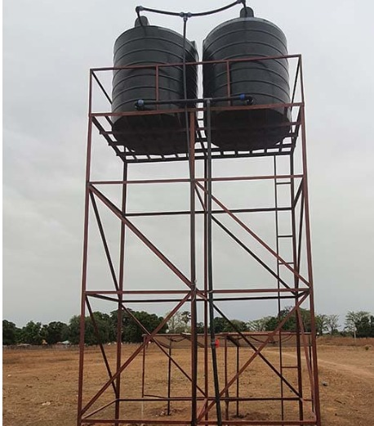

Figure 1 Watertower

# Table of contents

Inhoud

INFORMATION 2

**AUTHORS** 2

**PROFFESSORS** 2

**COMMISSIONING PARTY** 2

**IMPORTANT DATA** 2

1. PREFACE 3

**TECHNASIUM RESEARCH & DEVELOPMENT** 3

2. Summary 3

Table of contents 5

3. INTRODUCTION 5

**Introduction problem definition** 6

4. COMMISISIONING PARTY 7

**WATER WELL** 7

5. MISSION 10

**RELEVANCE** 12

**COMMISSION FINAL RESULT** 12

6. PRELIMINARY RESEARCH 12

**Life in Gambia** 12

7. PROGRAM OF REQUIREMENTS 13

8. DELIVERABLES 14

9. PLANNING 15

10. PROCESS AND COMPLICATION 16

11. LITERARY SOURCES 17

Bibliografie 17

# INTRODUCTION

## **Introduction problem definition**

There are more than two billion people who do not have access to clean water worldwide, this is one third of the world’s people. Every day, more than 800 children under the age of five die from causes related to polluted water, the lack of toilets and poor hygiene conditions. Our client is the foundation Amanaah, this foundation has been working for almost two years to offer clean water to more people by building wells and towers. Their mission is to help as many people as possible with this problem.

WHO and UNICEF warn that without significant additional investment, billions of people will still not have access to clean drinking water and proper sanitation by 2030. According to the UN organizations, the pace of progress must be quadrupled.

The WHO and UNICEF have also looked at basic hand washing facilities. This will be available to 78 percent of the world's population by 2030. This does not apply to 1.9 billion people. For comparison: in 2020 it was 71 percent. At the start of the corona pandemic, three out of ten people worldwide could not wash their hands with soap and water at home.

**(unicef, 2018) (world health organisation, 2017)**

Women sometimes have to walk miles every day before they can finally get to a water supply where they can get water, it is often very busy here and it takes hours to wait before it is finally your turn to get water. In the past period there have been several floods due to the rainy season and huts have been washed away in various villages. Various water supplies have also become unusable and people have to go further and further away to get water.

**(stichting Amanaah, 2021)**

The positive news is that steady progress is being made. Between 2016 and 2020, the percentage of people with clean drinking water at home increased from 70 to 74 percent.

# COMMISISIONING PARTY

The Amanaah Foundation is committed to sustainable support for villages in Africa. They started building self-sufficient wells in 2021. These wells are equipped with pumps that are powered by solar energy. Water is the basic necessity of life for every human being in order to survive, unfortunately this luxury is not for everyone. In many places in the world water is desperately needed and that is why the people at the Amanaah Foundation are doing these collections to help the people.

## **WATER WELL**

By means of solar energy, a pump is supplied with power by the Electricity Control Box that passes on the power to the pump. The water is then pumped up to a large storage tank of approximately 2000 to 4000 liters. Pipes are made to this storage tank that go to the places where the water is most needed and taps are placed through pipes and water can be used.

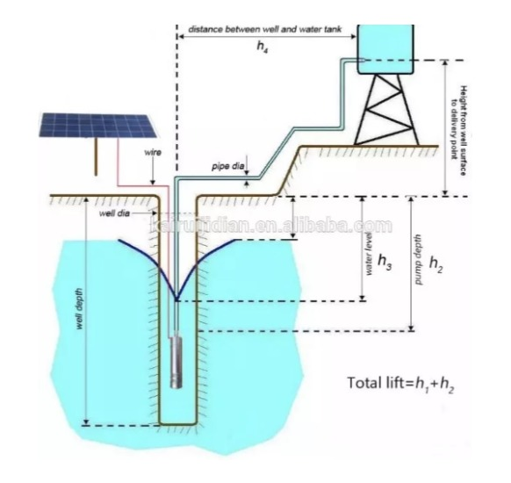

Figure 2

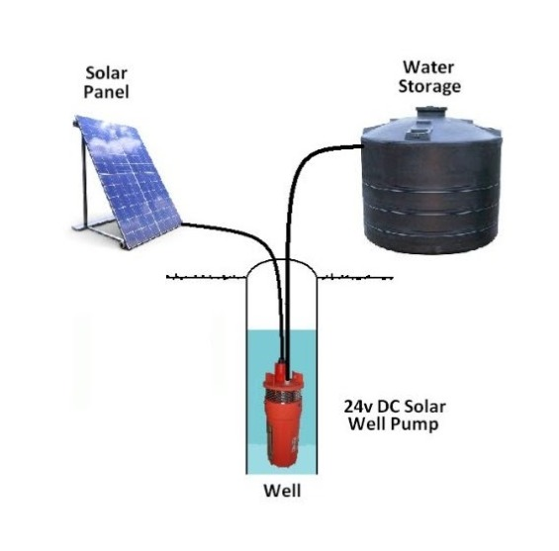

Figure 3

**CLIENT**  
Menno Huizer is the general manager at the foundation Amanaah. Together with his wife he started the Amanaah foundation. He named this foundation after his daughter. The Amanaah Foundation has already built several successful water towers in The Gambia. They have also made several videos about this. It is definitely worth taking a look at the site!

**(Stichting Amanaah, 2021)**

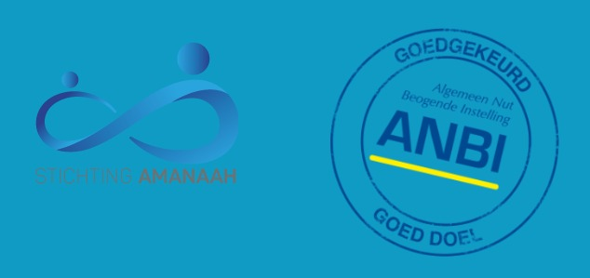

Figure 4

# MISSION

Our assignment is to collect money for a well in Gambia, so that we can build it there. We will be organizing activities on May 14 to collect the money. One of the activities is a football tournament, here we will work in group phases. For three hours, young adults will play football matches against each other, which will generate money. The other activity is a benefit, at the benefit there will be all kinds of stalls where we will sell different things (cupcakes, quotation of Arabic quotes, henna, etc.).

In this way we will collect the money for the well, when this is done, we will set a date on which the well will be built in The Gambia.

**FLYER**

For this project we have made a flyer containing all the information for the people who want to register for our activities.

See the flyer below.

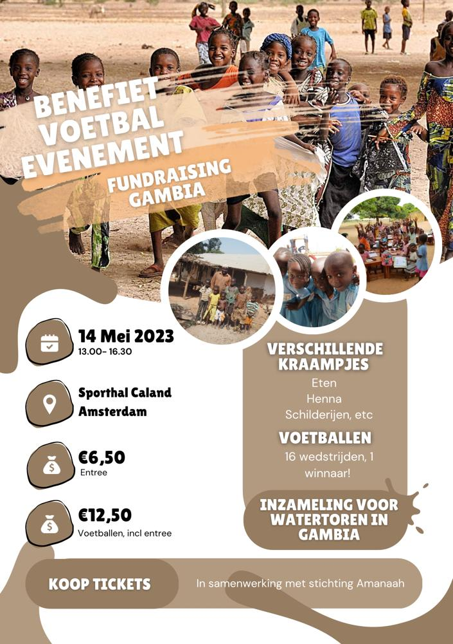

Figure 5

## **RELEVANCE**

The foundation Amanaah is committed to improving the quality of life of underprivileged people worldwide. By accepting the assignment, they can do this and ensure that children and their families have an opportunity to bring clean water.

## **COMMISSION FINAL RESULT**

We would like to see a great success in building the well/tower. We hope that many children/parents can use this and that we can make a small contribution to the fact that more people can use the clean water.

# PRELIMINARY RESEARCH

## **Life in Gambia**

Gambia is a small country in West-Afrika, bordered by the Atlantic Ocean and surrounded by Senegal. Gambia has one of the weakest economics in the whole world. With an average hourly wage of a euro, almost half of the population lives in poverty.

Life for the inhabitants is tough. Life is survival, as they say. They don’t have money and they almost can’t survive. The water quality in Gambia is also a great concern. The tap water in Gambia is not drinkable and drinking tap water can lead to serious bacterial infections. The life expectancy in Gambia is very low. According to research from the CIA World Factbook, this is only 53 years old. If you compare this with the life expectancy in the Netherlands, which is 86 years old, this is very low. Major causes of death are diseases such as typhoid, which in turn are caused by polluted ‘drinking’ water and the bad hygiene. Due to the lack of doctors and hospital, most of the people do not survive.

What also doesn’t help much is that Gambia is getting drier and drier. In the last thirty years, the amount of rain has decreased by 30%. Gambia has a tropical savannah climate, which means that the country belongs to the tropical climate zones. You will mainly find large dry grass landscapes with large trees in the country. Gambia has tropical temperatures. This is between 31 and 38 degrees Celsius during the day, throughout the whole year. Due to this enormous heat, many people suffer from sunstroke. This sunstroke can even lead to death, if not given the right help. Most people who die from this are children. More than 10% of the newborn babies in Gambia do not survive.

**(the world factbook, 2018) (Armoede in gambia, 2019) (Klimaat Gambia, 2020)**

# PROGRAM OF REQUIREMENTS

Because the project we are running this semester is quite a challenge to be handling, we made a strict plan in terms of planning the event and handling all the things that come with organising it. Immediately when we came up with the plan the first thing that came to our minds was renting the halls where we are planning to hold the events (football tournament and the ‘bazaar’). We also immediately took care of that, discussing the date and time it could be held with our client and the head of hall-renting of our school. After all this we came to a conclusion that we needed to invite people with a big platform, just so that we could spread the word of the event. We gathered names and emails to inform and invite them to our event. The next thing we did was make flyers to help us promote it. The flyers get printed out and hung up throughout the neighbourhood. What needs to be done is the social media part, making accounts on social media platforms such as Instagram, Snapchat and TikTok. This way we can spread our word and action even more since these platforms have a very high trafficking speed and width.

The next thing on our planning is making sure we have secured a fair amount of sponsors that are willing to help finance our cause. We also made a GoFundMe to seek support from individuals. While all this is happening we ask our friends and family for help on and around the event. We currently are working on a site where the people can buy their tickets for entrance and for the tournament.

After all this we are entering the last stage which is finding people who are willing to volunteer and sell food and goods at the bazaar. We will need to hire stalls where these people can put their goods and start selling. These are the biggest things that need to be done, we’re sure we will find other things to do along the way, but this already covers most of it.

# DELIVERABLES

***Requirements:***

**- Organize football tournament.**

**- Organize a benefit.**

**- The purpose of the money.**

**- Arrange sponsors.**

**- Arrange promoters**

Our client has drawn up different types of requirements for us. Which includes the football tournament and benefits. The goal is that we arrange 64 people at the football tournament to come and play soccer, including 8 influencers. We want to achieve this goal by fulfilling our other requirements and that is by promoting. We want to do this by making flyers and asking influencers to post this on their story. For the event to succeed, we need money to be able to invest things in the stalls that we want at our benefit. For the event to succeed, we need money to be able to invest things in the stalls that we want at our benefit. We want to achieve this goal by attracting sponsors and ensuring that they invest in us. With all the money we raise, we want to build a water tower.

|  |  |  |  |
| --- | --- | --- | --- |
|  | What does it entail | Conditions | Responsible |
| Deliverables apart from the assignments |  |  |  |
| Deliverable 1.1 | Weekly mail client | 1) write a mail with updates about what has been done.  2) Show the mail to the team  3) send it to the client | Nisrine |
| Deliverable 1.2 | Site management | 1) Make sure every document can be found on the website.  2) Available for all team mates. | Nisrine |
| Deliverable 1.3 | Schedule | 1 )Clear schedule.  2) Available for all team mates. | Sanae |
| Deliverable 1.4 | Action plan | 1) The frontpage must loop professional.  2) The font size needs to be professional. | Sanae |
| Deliverable 1.4.1 | AP Layout | 1) The frontpage must look professional.  2) The font and font size can be decided by you but must make sense for a professional AP. | Sanae |
| Deliverable 1.4.2 | AP introduction | 1) Make it an introduction to what the AP is about. | Sanae |
| Deliverable 1.4.3 | AP commissioning party | 2) Tell who the client is and why we choose him. | Sanae |
| Deliverable 1.4.4 | AP mission | 1) Tell in detail what the assignment is and with who we do it.  2)tell about the flyer. | Sanae |
| Deliverable 1.4.5 | AP Preliminary research | 1) Tell us what we did as a preliminary investigation.  2) tell what life in Gambia is like now. | Amber |
| Deliverable 1.4.6 | AP program of requirements | 1) Based on your preliminary research, you draw up a program of requirements for your design. You adjust this later, when you have clearer what your design looks like or will look like. | Iman |
| Deliverable 1.4.7 | AP deliverables | 1)Explain what the deliverables are and why they are needed | Nisrine |

|  |  |  |  |
| --- | --- | --- | --- |
| Deliverables Preliminary investigation |  |  |  |
| Deliverable 2.1 | Information Gambia | Gather all the details you can find about Gambia. | Amber |
| Deliverable 2.2 | General information Gambia | Find general information about Gambia. | Sanae |
| Deliverable 2.3 | Sponsors | Contact all kind of sponsors and remain the contact. | Nisrine |
| Deliverable 2.4 | Common projects | 1) Search for projects that are similar to ours.  2) The results of the search will be an fundament to the final solution.  3) At least 5 common projects. | Sanae |
| Deliverable 2.5 | Analyzing common projects | 1) A final conclusion about the usefulness of our project. | Nisrine |

|  |  |  |  |
| --- | --- | --- | --- |
| Deliverables  End product |  |  |  |
| Deliverable 3.1 | End report | 1) Find at least 10 different projects about re-greening deserts  2) The information can be obtained via the internet or by contacting external organizations  3) Ideas from the team are also welcome. | Sanae |
| Deliverable 3.2 | Presentation | 1)Presentation must be in a PowerPoint. | Nisrine |

# PLANNING

|  |  |  |  |  |  |
| --- | --- | --- | --- | --- | --- |
| **Week** | **General** | **Nisrine Hajjab** | **Iman Djebari** | **Amber Tallih** | **Sanae El Ouahabi** |
| Week 5  (31 jan tm 5 feb) | Personal Development Plan and competition monitor completed. |  |  |  |  |
| Week 6  (6 feb tm 12 feb) | Research client. + brainstorm technique completed |  |  |  |  |
| Week 7  (13 feb tm 19 feb) |  | Deliverables | Program of requirements | Preliminary research | Layout POA + Introduction, Mission, Client, preface, commission party |
| Week 8  (20 feb tm 26 feb) | Submit the PoA |  |  |  |  |
| Week 9  (27 feb tm 5 ma) | Found sponsors | Group website | Mailing list | Flyer | Called the client |
| Week 10  (6 ma tm 12 ma) | Preliminary research |  |  |  |  |
| Week 11  (13 ma tm 19 ma) | Preliminary research |  |  |  |  |
| Week 12  (20 ma tm 26 ma) | Personal Development Plan interim evaluation |  |  |  |  |
| Week 13  (27 ma tm 2 apr) |  |  |  |  |  |
| Week 14  (3 apr tm 9 apr) | TESTWEEK |  |  |  |  |
| Week 15  (10 apr tm 16 apr) |  | Go fund me |  | Have booths ready for the benefit | Have booths ready for the benefit |
| Week 16  (17 apr tm 23 apr) | Promoting the football tournament and the benefit + flyers |  |  |  |  |
| Week 17  (24 apr tm 30 apr) | Preparing for the activities |  |  |  |  |
| Week 18  (1 may tm 7 may) | Preparing for the activities  + Final repport |  |  |  |  |
| Week 19  (8 may tm 14 may) | Planning the football tournament and the benefit |  |  |  |  |
| Week 20  (15 may tm 21 may) | Personal Development Plan final evaluation |  |  |  |  |
| Week 21  (22 may tm 28 may) | Preparing for Technasium parade + list for steps for building a water well/tower |  |  |  |  |
| Week 22  (29 may tm 4 june) | Technasium parade! |  |  |  |  |

# PROCESS AND COMPLETION

We will provide weekly updates to our client. During these moments we show what we already have and if there is anything new since the last time we spoke. If so, we ask for feedback, tips and tops. We will then implement this, and the teacher can, if desired, check this with the client. We will have the final presentation JUNE 12 during the Technasium parade. Here we present our deliverables through a presentation and with our prototype.

Our assessment takes place after the final presentation by means of a reflection form, of each team member in combination with the assessment of the client and the teacher.

# LITERARY SOURCES

# Bibliografie

*Aan de slag voor een lach*. (2021). Opgehaald van https://aan-de-slag-voor-een-lach1.webnode.nl/

*Armoede in gambia*. (2019). Opgehaald van https://www.wildeganzen.nl/help-mee/armoede-in-gambia

*Klimaat Gambia*. (2020). Opgehaald van https://klimaatinfo.nl/klimaat/gambia/

*stichting Amanaah*. (2021). Opgehaald van https://stichtingamanaah.nl/

*Stichting Amanaah*. (2021). Opgehaald van https://stichtingamanaah.nl/

*the world factbook*. (2018). Opgehaald van https://www.cia.gov/the-world-factbook/countries/gambia-the/

*unicef*. (2018). Opgehaald van https://www.unicef.nl/

*world health organisation*. (2017). Opgehaald van https://www.who.int/